## Extract Parenthesis

Write a JS function that when **executed**, extracts all parenthesized text from a target paragraph by given element ID. The result is a string, joined by "; " (semicolon, space).

### Input

Your function will receive a **string parameter**, representing the target element ID, from which text must be extracted. The text should be extracted from the DOM.

### Output

**Return a string** with all matched text, separated by "; " (semicolon, space).

### Examples

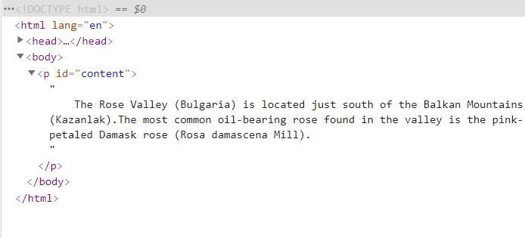

|  |
| --- |
| **Sample call** |
| **let text = extract("content");** |
| **Result (stored in variable text)** |
| **Bulgaria; Kazanlak; Rosa demascena Mill** |